Strengthening Alliances – Sudden Opportunity Campaign Funds
Who can apply? 1
How much can we apply for? 2
What is the application deadline? 3
What is the decision-making process? 3
How To Apply: 3
Step 1 - Select the lead organisation and provide their contact details 3
Step 2 - Complete the eligibility section 4
Step 3 - Complete the inclusion section 5
Step 4 - Provide the lead organisation’s registration details 5
Step 5 - Explain your campaign or influencing idea 6
Step 6 - Document Upload 7
Step 7 - Submit 9
Step 8 - Respond to any additional requests for information 9
Frequently Asked Questions 9

Activists and organizations can amplify their influence by working together.
The Strengthening Alliances - Sudden Opportunity Campaign Fund aims to further stimulate and facilitate collaboration. It will enable responses to chance circumstances and unique influencing opportunities with the possibility for change when groups can work together.

Who can apply?
- Organisations working collectively (2 or more groups working together), in new or existing collectives or alliances seeking to strengthen their advocacy efforts or seize a sudden campaigning opportunity.
- One of the applicant organisations must be a current partner of the Power of Voices Programme AACJ or FAIR for ALL through its consortium members:
African Activists for Climate Justice (AACJ) Consortium Members (PACJA, Natural Justice, Femnet, African Youth Commission, Oxfam Novib)

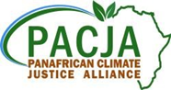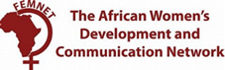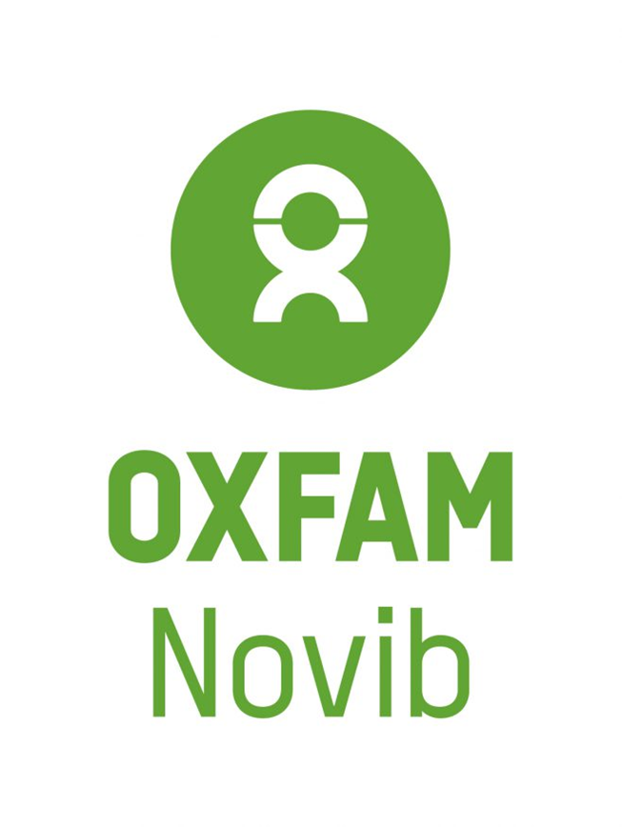

FAIR for ALL Consortium Members (Huairou Commission, TWN Africa, SOMO, Oxfam Novib)
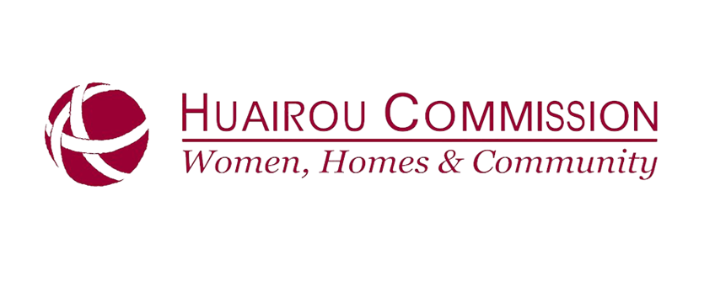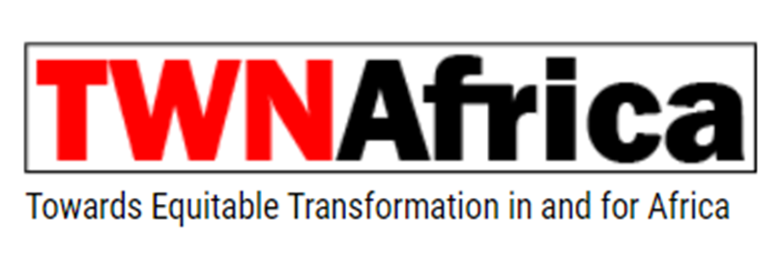

  - For this fund, the lead applicant organisation must be legally registered,
  - Consortium Members are encouraged to share this funding opportunity with their partners but not apply for themselves,
  - Priority will be given to partners representing under-funded and under-representative groups.

Applications will be assessed against the programmes’ Theory of Change with a focus on funding actions related to lobby, advocacy, campaigning, caravanning, convening or other creative ideas (such as, art as activism) that contribute to the Fair For All or African Activists for Climate Justice objectives:
    - FAIR for All: A strengthened Civil Society which is capable of creating space and mobilizing people across geographies to demand and contribute to more inclusive and sustainable trade and value-chains that respect human rights, protect the environment and promote women’s economic empowerment. This implies rebalancing developing countries’ reliance on dominant primary-commodity value chains, reforming tax and trade regimes and increasing investment in local and national value chains that benefit small-scale farmers, workers and artisanal miners; in particular women and their communities.
    - AACJ: Women, youth, local and indigenous communities can defend and realise their human rights and living dignified life in a healthy and sustainable environment, within the context of climate change.
Not eligible: This fund does not support humanitarian aid, planned programme activities (those in your annual workplan), infrastructure or traditional development work. This fund is not able to supplement funding for already planned activities, but is available for strengthening alliances to respond to a new or sudden influencing opportunity.

How much can we apply for?

Applicants can request between EUR 10.000 and up to 100.000 on behalf of a collective, to contribute or strengthen their work to respond to the sudden opportunity. It is anticipated that the average grant will be around EUR 25.000. EUR 500.000 in 2022 is available to provide support for collective action initiatives to either strengthen an alliance or respond to a sudden opportunity.
- What types of actions can we apply for?
The funds are meant to be flexible, with a focus on strengthening alliances in order to respond to unplanned opportunities for influencing.
Examples include, but are not limited to:
- Coming together to jointly mobilize and organize their constituencies and audiences offline and online,
- Bring in women (and other under-represented groups) movements and voices to allow for increased representation and ownership,
- Strengthening the network and complementarity of roles by creating opportunities for new or innovative approaches,
- Linking national alliances to global networks and platforms to leverage external support for their own asks, and
- Providing seed money to support the activation of (new) alliances on emerging issues,
- Support for national and regional ‘Caravan to COP27’ actions under AACJ

What is the application deadline?
This fund is open until the end of 2022 (with the intention to receive applications on a rolling basis until the end of the Power of Voices Programme) which allows applications for sudden opportunities that may arise throughout the programme duration. The idea is to provide flexible funding to respond to opportunities not present at the time of annual planning and that was not budgeted for.
Funds will be assessed on a rolling basis with the decisions to be made within 4 – 6 weeks.
Please indicate the start date when you will need the funds in order to take action.
Note: programme partners with underspend may be asked to first re-allocate unspent resources before being provided with additional funding. This will be addressed on a case-by-case basis.

What is the decision-making process?
Applications will be scored by the external fund advisory committee and representatives from the projects based on:
- The suddenness of the influencing opportunity and proposed timeline,
- The relevance of the idea and its link to the programme objectives of Fair For All or African Activists for Climate Justice,
- The type of alliance or collective requesting funding and the distribution amongst partners (with the priority to resource under-funded groups to increase their influencing),
- The availability of funds and distribution of resources between countries/regions and topics.

How To Apply:
Link EN: https://www.cognitoforms.com/OxfamNovib1/SuddenOpportunityCampaignFunds
Link FR: FR Fonds de la campagne Opportunité soudaine (www-cognitoforms-com.translate.goog)
Link PT: PT Fundos de campanha de oportunidade súbita (www-cognitoforms-com.translate.goog)

Applications will be received via the form link. There are eight steps to the application.

Step 1 - Select the lead organisation and provide their contact details
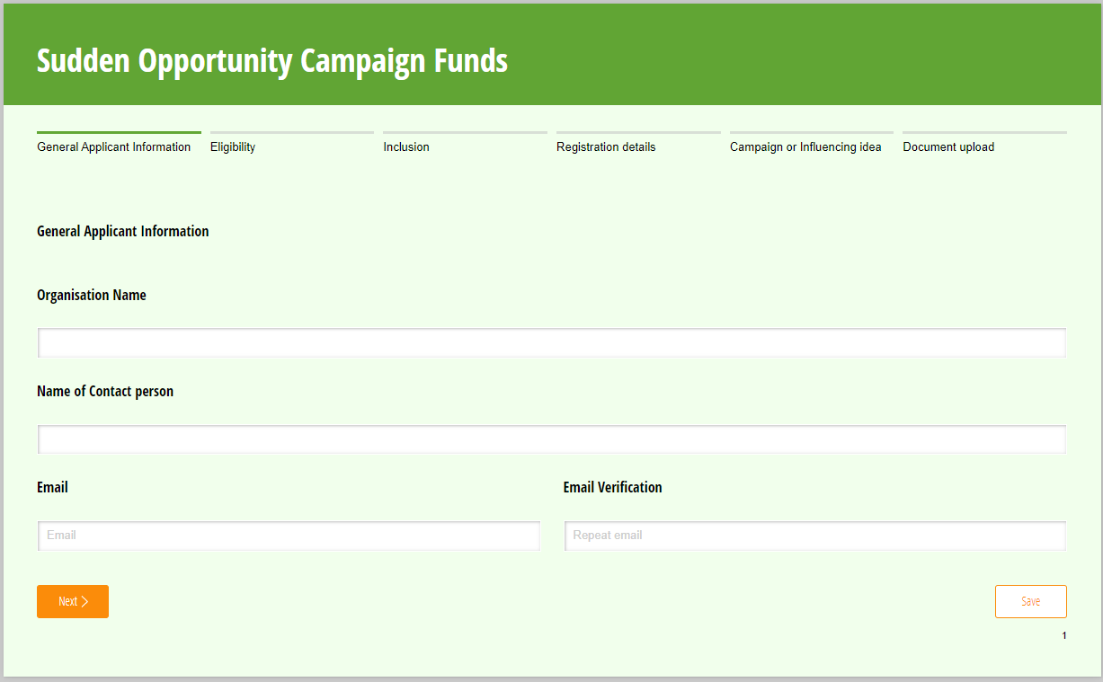

Step 2 - Complete the eligibility section
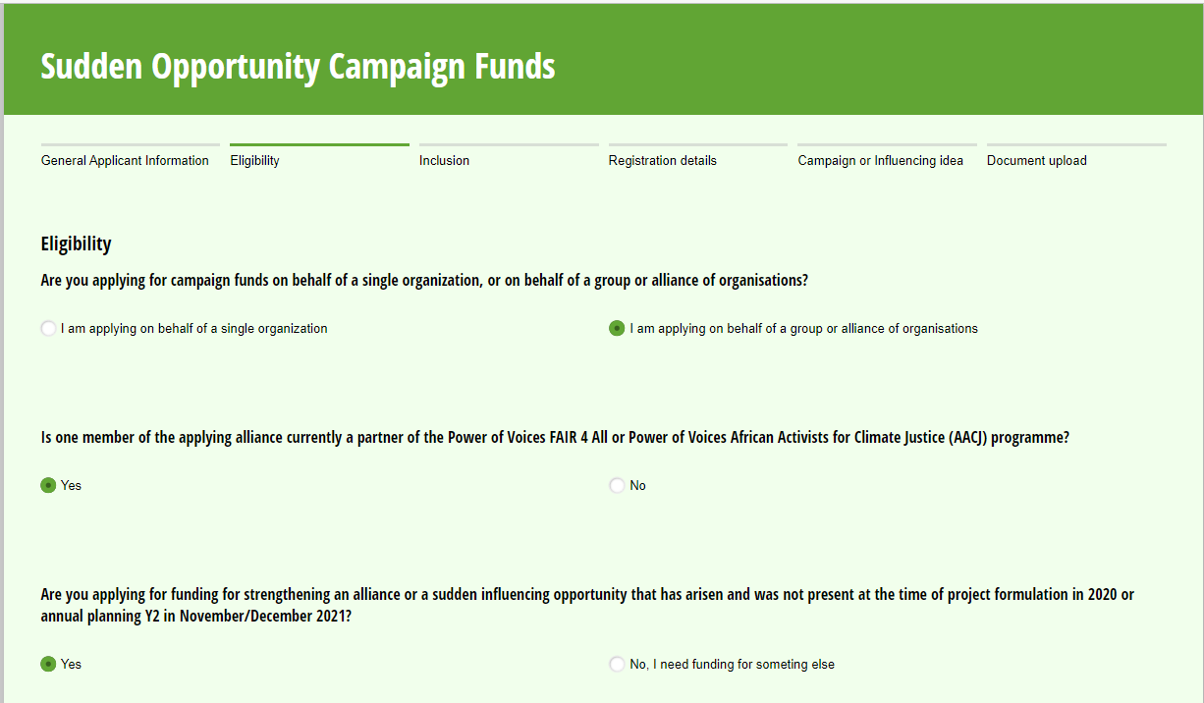
Note in this section you must identify which Power of Voice Programme you are partnered with (AACJ or FAIR for ALL) and which consortium member you are a partner of (FAIR for ALL: Huairo Commission, SOMO, TWN Africa, Oxfam Novib or AACJ: PACJA, Femnet, Natural Justice, AYC, Oxfam Novib).

If you are partnered with more than one organisation, choose the primary organisation for the Power of Voices Programme. You will also need to provide the email of your contact at the consortium member.

You will be asked to identify which country or region you plan to carry out your action in.

If you are applying for funds for the ‘Caravan to COP27’ please indicate so that the correct people can assess your application.

Step 3 - Complete the inclusion section
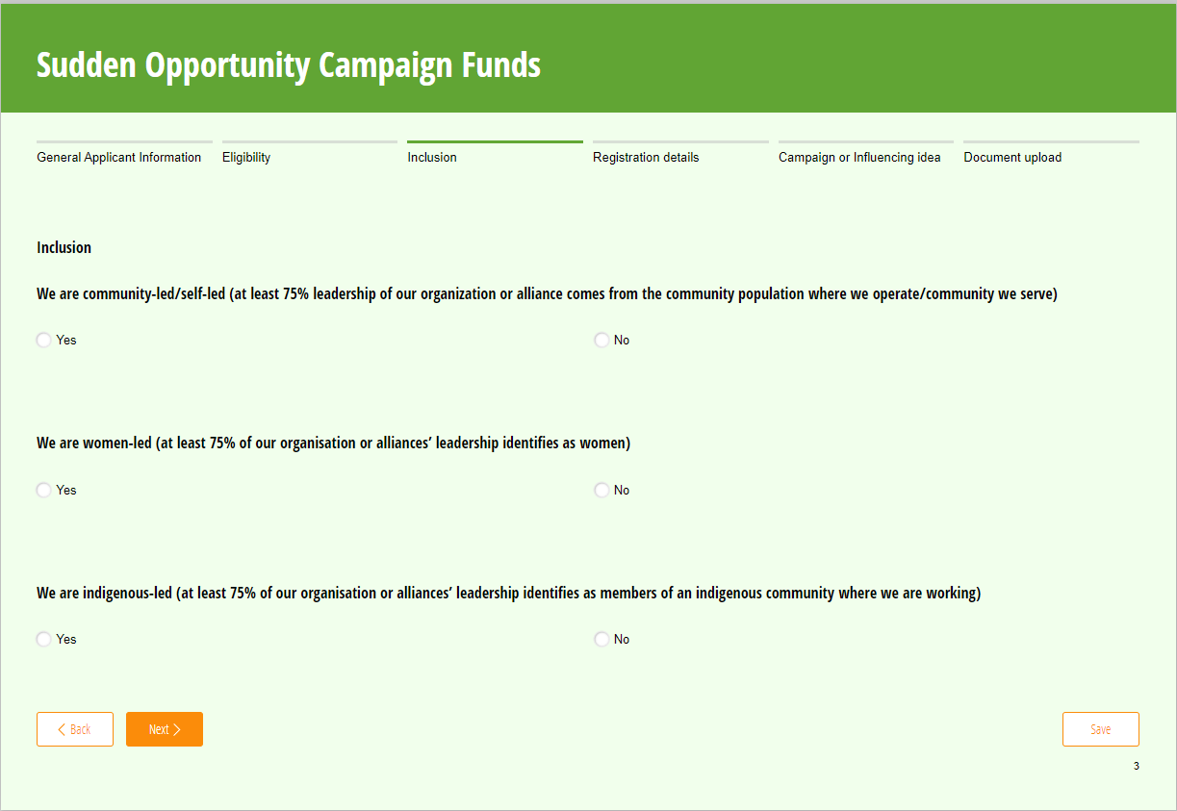
Note: Answering no to any or all of these questions will not disqualify you, but will allow us to identify underfunded or under-represented communities in the assessment process.

Step 4 - Provide the lead organisation’s registration details
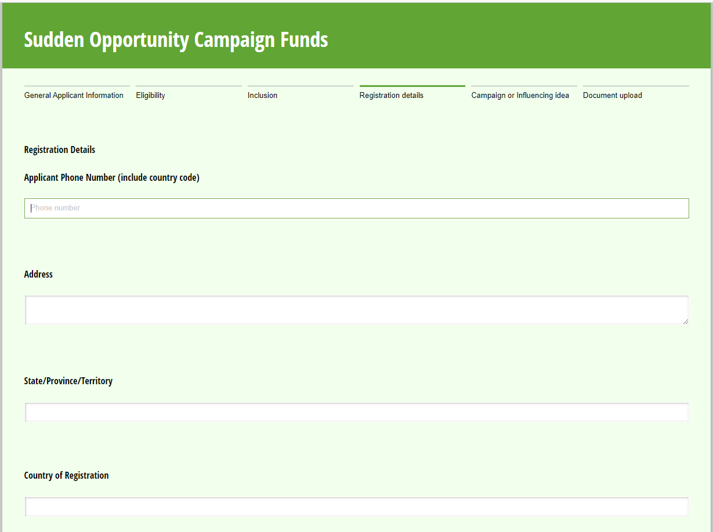
Note you will be asked if the lead organisation has or has had a financing agreement with Oxfam. Partners who are already in the Oxfam Novib system will not need to undergo additional due dilligence.
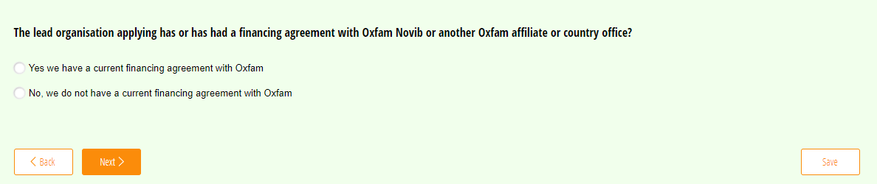

Step 5 - Explain your campaign or influencing idea
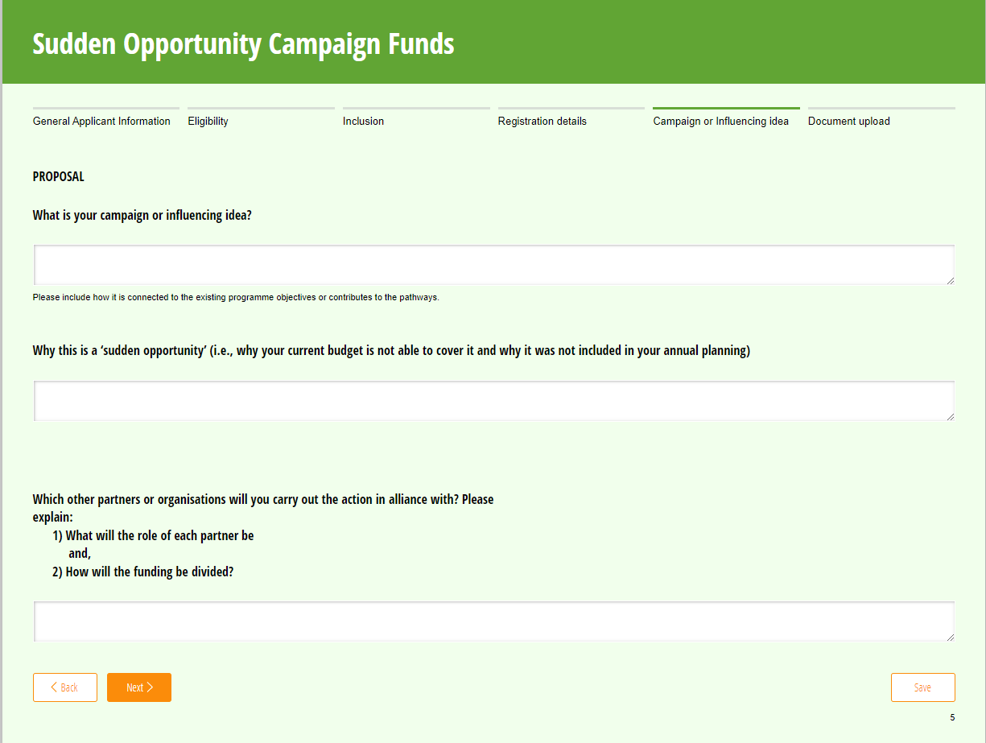

The proposal consists of the following questions:

- What is your campaign or influencing idea
- Why is this a ‘sudden opportunity’ (i.e., why your current budget is not able to cover it and why it was not included in your annual planning)
- Which other partners or organisations will you carry out the action in alliance with? Please explain:
  - What the role of each partner will be?
  - How the funding will be divided?
- What your organisation’s annual operating budget is (in EUR)?
  - What the budget of the opportunity is (in EUR)
  - What amount you are requesting from the fund (in EUR)
- The date you need to start your activities by
  - Additional details on your timeline
- Optional: if you have capacity strengthening needs that will help you carry out your action. You can include this in your budget for consideration.

Step 6 - Document Upload
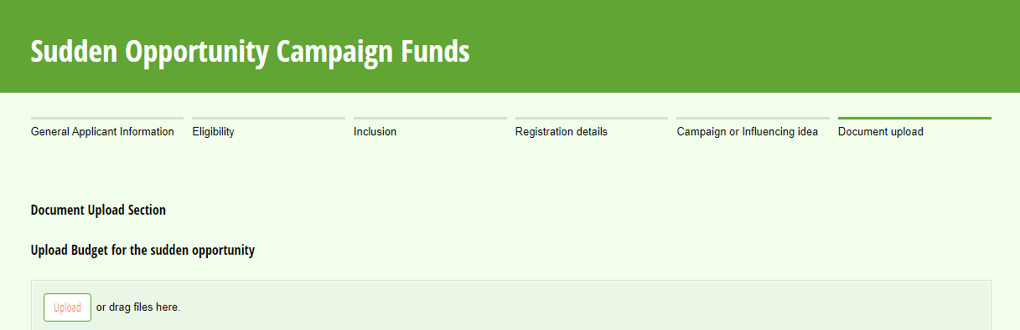
The following documents will be requested from all applicants:
- Required: Budget (see template here: https://oxfam.box.com/shared/static/j1su1zjn33cuaixygvy9t7cqpmbid5wz.xlsx )
- Optional: Additional documents to support your application

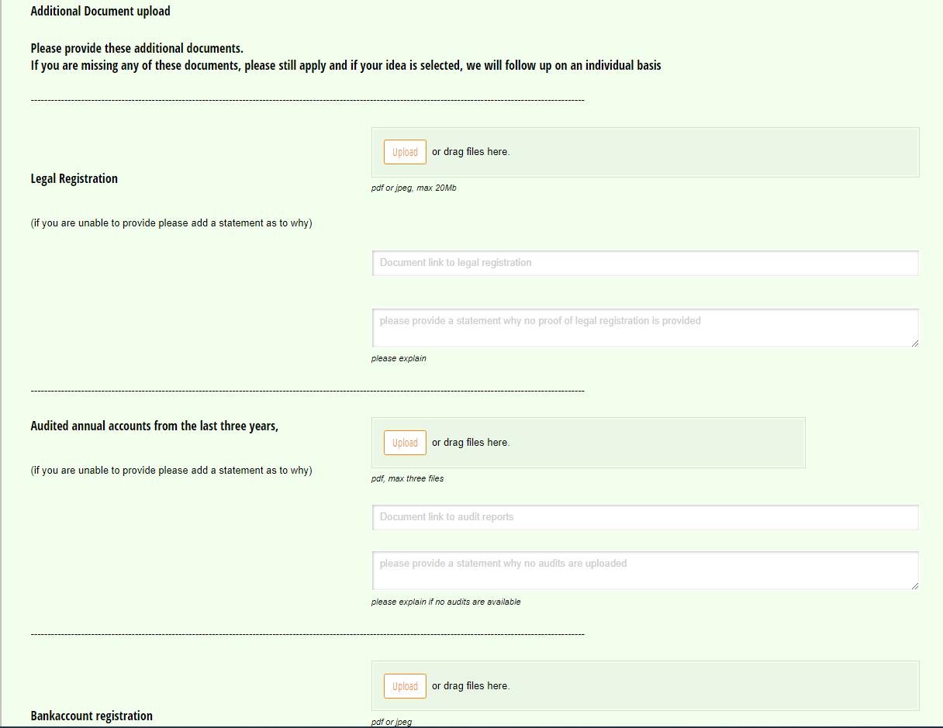
Additional documents will be requested from those who do not have a financing agreement with Oxfam. You can upload a copy, provide a link if the information is already available online, or provide an explanation if a document is not available.

Note: the more information you can provide at this stage, the faster the due diligence check can be conducted, but if you do not have all the documents, you are still encouraged to apply.
- Legal Registration
- Audited accounts (from the last three years)
- Bank account registration
- Gender Justice and Social Inclusion policy or statement
- Safeguarding Policy, statement or complaints mechanism
- Policy statement regarding fraud and/or corruption

Step 7 - Submit
Once you have provided all the requested information, you can submit your application.

Note that there is an option to save your application as you are working on it.

Step 8 - Respond to any additional requests for information

During the review process, there may be additional requests for information. Please respond to these are quickly as you can to keep the process of review going.

We will aim to make decisions within 4 – 6 weeks.

Frequently Asked Questions

This section will be updated as questions are asked.

- Can Oxfam Country Offices apply for funding?

In theory—yes—however the intention is to enable partners to apply for funding where possible. Applications must be made by two or more organisations in alliance.

- Can we fund partners that we do not have an official financing agreement with?

Yes, but one organisation should take the lead in applying.

- Can non-AACJ or FAIR for ALL countries apply for funds?

The first priority will be for countries who are connected to the Power of Voice Programme country locations, however, if there is a clear link to the programme objectives (for example, an non-AACJ African country wanting to apply for funds for the ‘Caravan to COP27’), then your application will still be considered.

- If I am applying from a non-AACJ active country for the ‘Caravan to COP27’, am I still allowed to apply?

Yes, Caravan to Cop27 applications should indicate in the form that they are applying under the Power Of Voices Programme AACJ and indicate that they are applying for the ‘Caravan to COP27’ so their applications can be processed quickly.

- Can we still apply if we don’t meet the inclusion criteria?

Yes, selecting ‘No’ on any of the inclusion questions will not disqualify you from funding, but in the case that a difficult decision needs to be made, being a community-led, women-led or indigenous-led alliance will be taken into consideration.

- How are ‘indigenous’ people defined?

While there are several definitions of indigenous (or aboriginal) people groups, for this fund we will prioritiseindigenous peoples who have social, cultural, economic, and political characteristics that are clearly distinct from those of the other segments of the national populations where they reside. Indigenous people are considered only 6% of the worlds population but are thought to be defending 80% of natural resources, while fighting to maintain ways of life on lands from which their people came prior to setter-colonial occupations.

- What is the period of the funding?

The fund is rolling, which means it will hopefully remain open for the duration of the Power of Voice Programmes (until 2025). As it is meant to be unplanned or sudden opportunity funding that you could not budget for in your annual plan, we anticipate that most funds will be used within a short-time span (less than 12 months).

- What is the budget ceiling?

Alliance can apply for an amount between EUR 10.000 up to EUR 100.000. Note that we anticipate providing an average funding of around EUR 25.000 and larger requests will be treated more competitively and will take longer to process.

